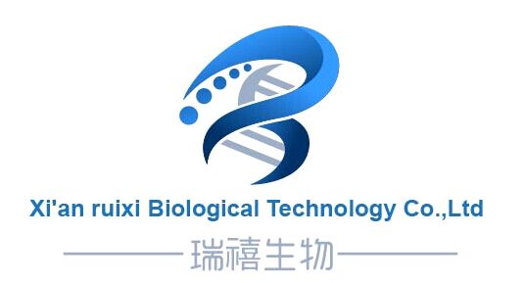
西安瑞禧生物科技有限公司
Xi'an city ,Shaanxi Province,China
Web:http://www.xarxbio.com
Tel: 0086 29 86354885
E-mail:sales@xarxbio.com

Certificate of Analysis

General properties:
Name： HO-PEG3400-PDLLA5000
Molecular Weight：PEG MW:3400 PDLLA MW:5000
Cat.#： R-1079-35K
Lot.#： RP0162571
Date of Analysis： 2016.07.25
Recommended Retest date： 2017.07.25
Stability： 12 months
Storage： -20°C in the dark

Structure

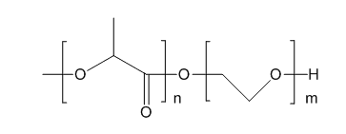

Items | Specification | Results
Appearance | White to off-white solid | off-white solid
¹H NMR | Identical to the structure | Identical to the structure
Foreign Material | None | None
Substitution | ＞90% | 90%
Report Date: 2016.07.25

This product is for research use only, Not for human or animal use

